**Project Coordinator**

**3SR Project**

**Apply here**

[**https://rb.gy/nmoly**](https://rb.gy/nmoly)



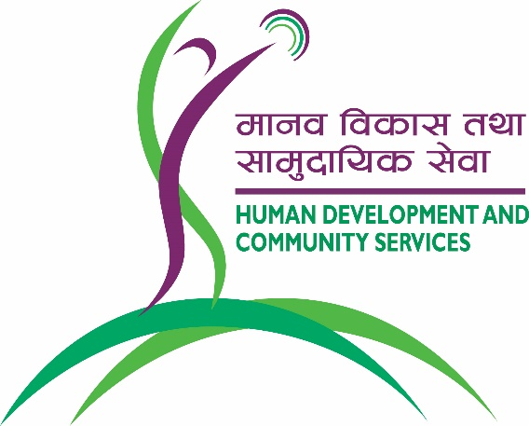

|  |  |
| --- | --- |
| **Project Location :** | Chaurjahari, Rukum West, Nepal |
| **Service type :** | *Samriddha ra Surakshit Samudaya Rukum* (3SR) Project |
| **Type of Contract :** | Yearly contract for three years |
| **Post Level :** | Mid-level management |
| **Reports to:** | Community Development Programme Manager |
| **Supervisory role:** | 10-15 people |
|  |  |

**Organisation Background:**

Human Development and Community Services (HDCS) is a faith-based NGO working in three main sectors of health, education, and community development since 1991. Currently, it manages various projects across Nepal especially in rural areas and provides services through hospitals, health camps, public health programs, disaster preparedness and response, school development programs, teacher training, educational daycare centres for children with special needs and community radio stations. The organisation is implementing *Samriddha ra Surakshit Samudaya Rukum (3SR).*

HDCS is committed to attract and retain the best employees from all ethnicities, gender and backgrounds in its vision to transform the communities by creating sustainable livelihood income.

**About project:**

HDCS is working closely with farmers, small and medium level entrepreneurs by creating integrated new concept of One Health approach and now linking with this a new project is being developed which is called ***S****amriddha ra* ***S****urakshit* ***S****amudaya-****R****ukum (3SR).* HDCS is willing to expand its collaborative effort with local stakeholders to scale up the initiative linking with various other projects so that 3SR is able to support farmer groups to systematize regular saving, establish small business, create local job and start up market promotion of local product. By doing this, HDCS would be able to establish and promote value chain linking with entrepreneurship in livelihood.

**Responsibilities:**

Project Coordinator will be primarily responsible for overall project activities and coordination with different projects, farmer groups, small and medium business entities, government units, cooperatives and team. there will be separate Team Leaders for health component and Livelihood whom proper guidance and leadership needs to provide by this role. To ensure they are trained, developed and are able to implement as well as track technical part of the mother/farmer/child club/ youth club/ government technical people/ health post/teacher and other entities working in the respective area. Through the proper leadership they are able to create synergy by findings resources to add value while implement the project effectively.

**Deliverables:**

* Manage project staff to ensure all activities are carried out according to the project plan and budget
* Timely activity and financial reporting to line manager
* Monitor and evaluate project to ensure outcomes are achieved
* Develop and plan for training events and materials
* Provide training to selected farmers, students, health workers, teachers, mother groups as per need
* Identify potential community groups and bring them up
* Equipment and advice for the establishment of model enterprises
* Conduct community stakeholder meetings
* Establish effective value chain of cooperative, market, BF institutions and health post

**Requirements:**

* At least a bachelor’s degree or above with specialization in the fields of Agriculture, Business marketing, Forestry, Livestock, Nutrition Science, Development studies, Project Management, Environmental Science, Natural resource management or other relevant field.
* Minimum 3 years of relevant work experience.
* Equipped with result-based management skill with dynamic team player capacity.
* Self-motivated and comfortable working in rural situation.
* Strong analytical problem-solving ability and creativity to bring new systems to the project.
* Experience in business promotion, WASH, Livelihood, Cooperative management, agro-based marketing etc.
* Learning attitude and willingness to develop technical expertise.
* Strong verbal and written communication skills in English and Nepal.