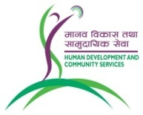 **Vacancy Announcement**

**Date of Publication: 12thMarch 2020**

Human Development and Community Services (HDCS) is a non-profit, NGO working in health, education and community development since 1991. It currently manages three hospitals in different districts of Nepal. HDCS is looking for committed and service-minded Nepali citizens for the following:

**Post: Medical Officer**

**Vacancies: Few**

**Qualifications and experience**: MBBS from recognized medical university with registration of NMC with minimum one-year work experience.

Salary and benefits as per organization’s rule.

Interested candidates please submit a CV with a cover letter by email to HDCS within 15 days of this announcement. Only shortlisted candidates will be contacted for interview.

Email address: [sudip.hdcs@gmail.com](mailto:sudip.hdcs@gmail.com)

Website: [www.hdcsnepal.org](http://www.hdcsnepal.org)